**Gems Sorting Machine**

**(Based on Artificial Intelligence)**

Utkarsh Gupta

Tanya Malhotra

Vanshaj Goel

(UPES Dehradun)

**Introduction**

In today’s busy world, when we have an opportunity of reducing the work on man’s shoulder, then why not implement it! Sorting an item based on its colour or attributes is a time consuming task. That is why colour sorters are highly usable in big industries for separating items according to their colour and in filtering the things which do not fall within the acceptable criteria or which are desired by the user.

Similarly, gems sorter machine is used to arrange multi coloured gems individually and is also based on Artificial Intelligence which is rapidly booming nowadays.

**Features**

1. With a really immense user interface, this machine is extremely easy to use as well as control.
2. The neural network is well trained with real time practical data.
3. The software (the main Python application) is efficient as it clicks a picture and crops it to the specific size of a gem.
4. Due to a properly constructed and coherent neural network, this machine is having an accuracy of approximately 93%.
5. New colours can be added to the system without any hassle.
6. The good design of the system promotes easy addition and removal of objects.

**User Interface**

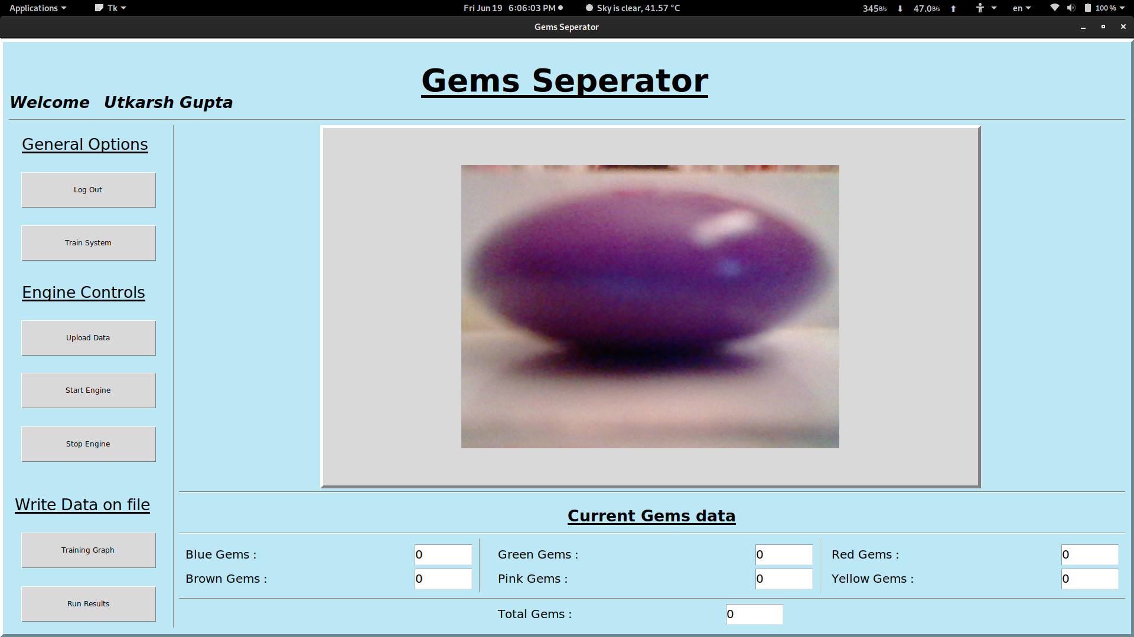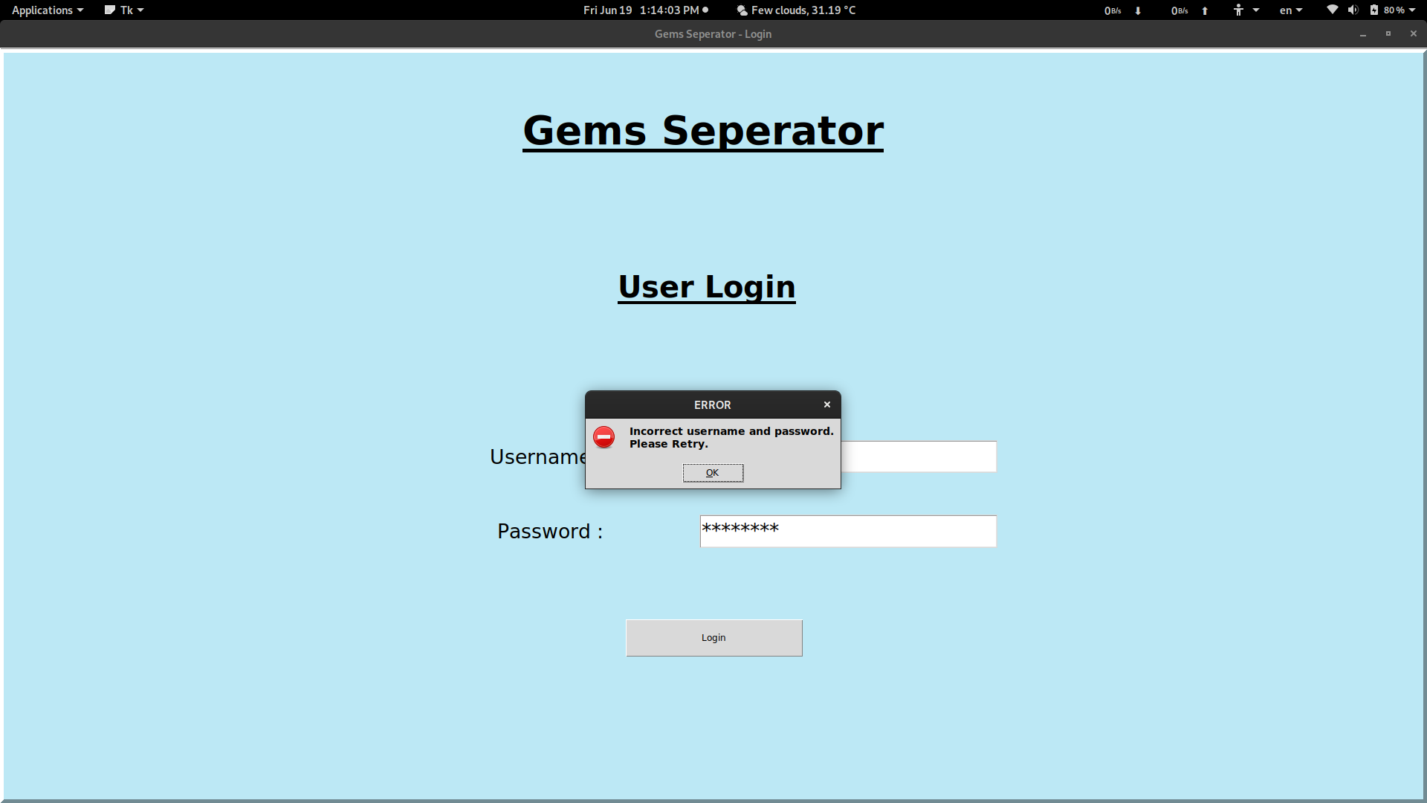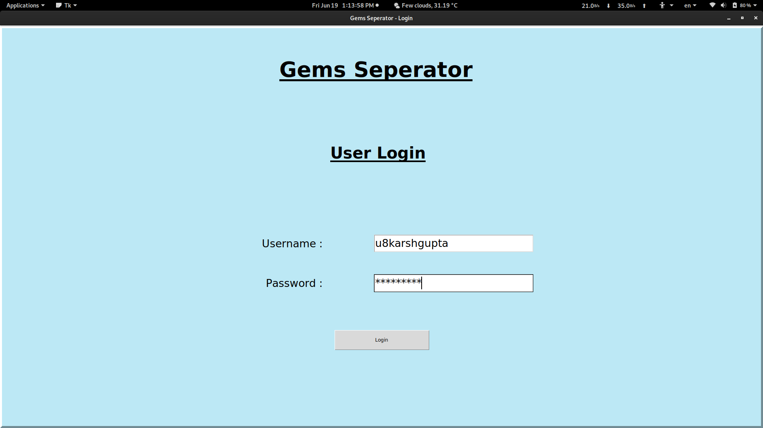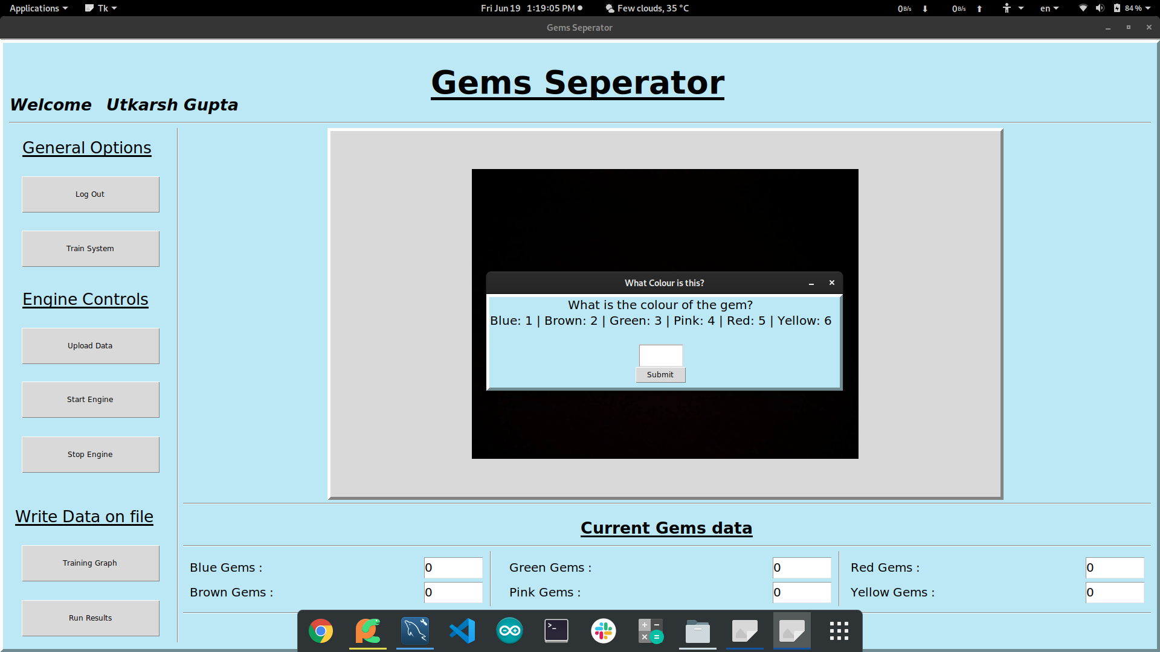

**About Neural Network**

* With the help of some fundamental knowledge of a neural network, a neuron was created.
* Sigmoid function was used as the activation function of artificial neuron.
* Taking note of the expected value as the output, the error was calculated with the help of sigmoid function and the expected value.
* Three main parameters were considered matching up to a specific colour constituent of an RGB colour model i.e., an additive colour format consisting of broad range of red, green and blue colours.
* The hardware component of the machine puts the multi-coloured gems on a conveyer belt and moves it.
* After the determination of colour of the gem, it is converted into the above mentioned RGB format.
* This in turn is provided to the Neural Network which notifies about the actual colour of the gem.
* 

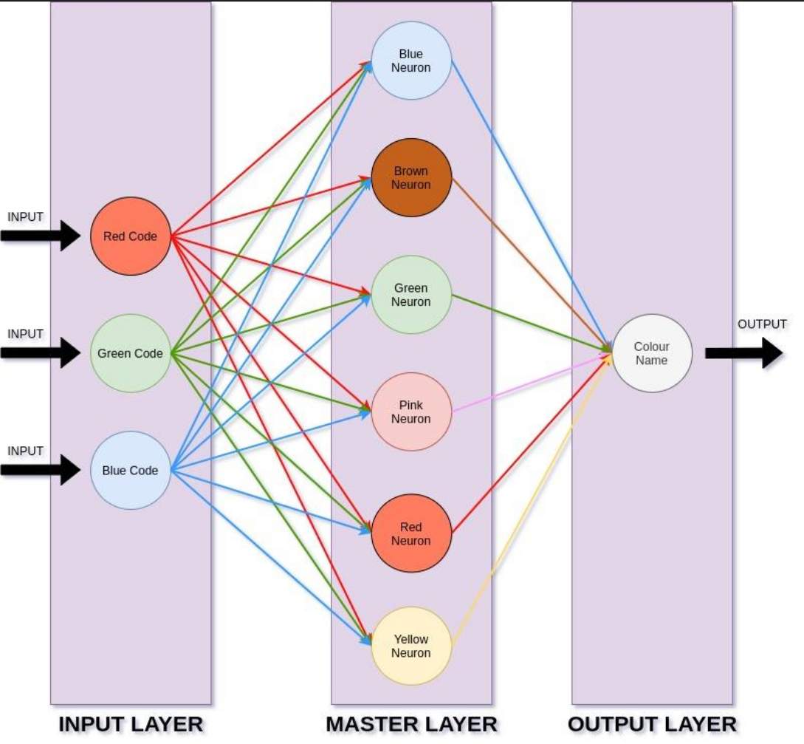

**Working**

The main software which is a Python application clicks a picture and crops it to the specific size of a gem. The colour of the gem is extracted and is converted into the RGB format. After sending the information to the neural network, the exact colour is determined which is provided to the GUI. The major loop informs the Arduino through serial communication, ultimately dropping the gem in the assigned box according to the output of the software.

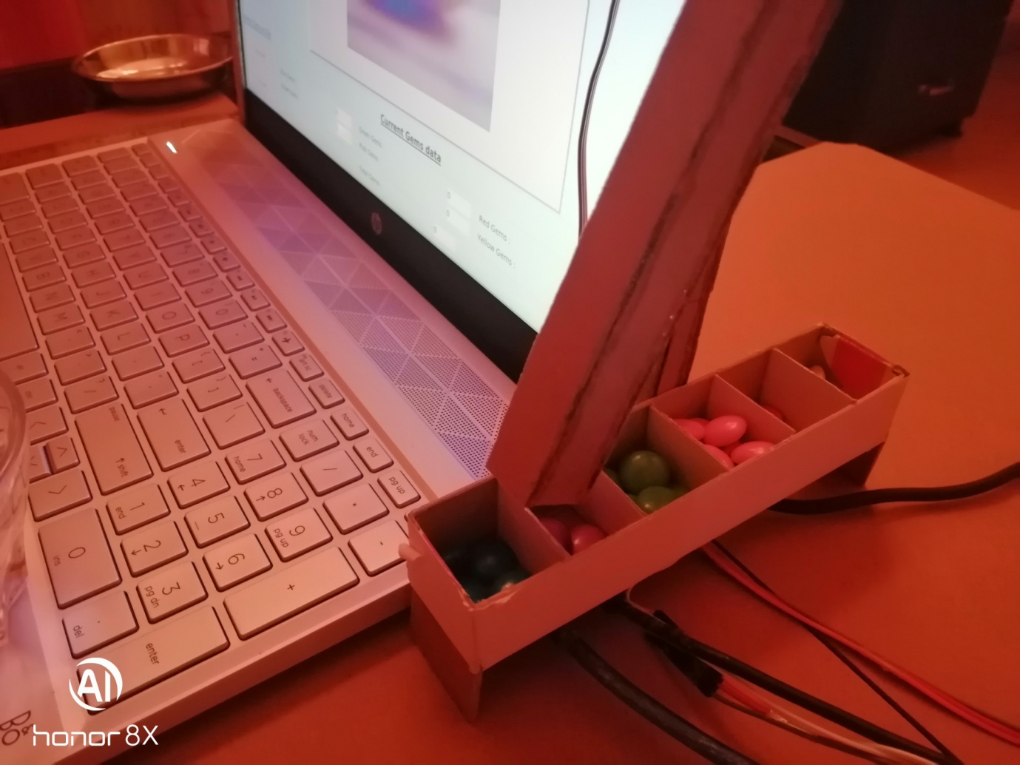

**Conclusion**

So, here we have got a pretty efficient sorting machine, which is not only very convenient to use but also has an extremely attractive design structure. The user interface is friendly and accuracy rate is unbelievably very high. The gems can now be easily differentiated and assigned into different boxes according to their colour. This machine can also be modified for some big items on a larger scale.

**Market Survey**